**Fourth area of Git – Remote Repo**

* Remote-Repo: This represents git repository somewhere else  
  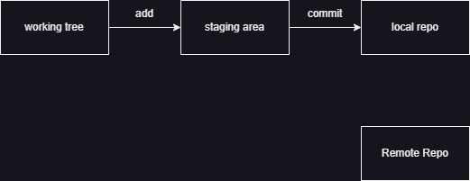
* Any software which hosts git-repo is called as git servers or git hosted repositories
* Git Remote Repositories can be hosted by many platforms/servers
  + Self-Hosted:
    - Gitolite
    - Git-lab
  + Cloud-Hosted or Git as Service
    - GitHub
    - BitBucket
    - Azure Source Repos
    - AWS Code Commit
* Git repository will have connection to remote-repo and a name to it. Default remote connections name is origin
* Cases
  + if you have local repo and then if you have created remote repo
    - remote add to add connection
    - push to send your git objects
    - pull to get git objects
  + you have remote repo already and you need local repo in your system.
    - clone
* When a remote repo is connected git branch -r will show remote branches
* Git pull has two variants
  + pull: this might lead to extra merge commits
  + pull with rebase: this will not lead to extra merge commits
* Pull operation is fetch + merge
* pull or push command require name of remote and branch names

git pull origin main

git push origin main

* if you want to set default remote and branch then we can set upstream branch

# While first creation of branch and pushing

git push -u origin main

**Tags**

* Git reference objects refspec
  + Branches
  + Tags
* Tag points to specific commit and it doesn’t move like branch
* We have two types of tags
  + lightweight tags
  + animated tags

### Lightweight Tags

Lightweight or Unannotated tags are just pointers to specific commit points. A lightweight tag just stores the hash of the commit it points to and no other information. They are mainly used on local systems only and it is not recommended to push them to the remote repository as they do not add much value. We can view the tags by navigating to the .git/refs/tags directory. We can see that the content of the lightweight tag file contains just the hash of the commit where we created the tag.

### Annotated Tags

Annotated tags are tags that contain additional information and not just the hash of the commit. The additional information (called **metadata**) can have fields like the type of object the tag points to, the name and email of the person who created the tag, a tag message. They even have their own hash as they are objects and not just pointers. Annotated tags should be used if the branch is to be pushed on a remote repository. To view all this information, we first need to get the hash of the tag from the .git/refs/tags directory. Then run the following to see its content.

